FALCON Buoy Design Options for DOST Approval
Project FALCON 01 Thesis Design Validation Package
Prepared for review of the proposed buoy form factor before fabrication and field validation

Purpose and decision requested
Purpose. This document presents the three current 3D buoy design options for DOST design approval. The intent is to help the panel compare the form factor, equipment placement, mooring approach, likely fabrication difficulty, and validation risks before the team proceeds with detailed build planning.
Main recommendation. Option A is recommended as the primary design because it is the smallest and simplest body while still showing the required water pressure, wind, GPS, power, internet, warning light, and mooring elements. Options B and C remain backup designs if the panel prioritizes stability or deck access over compact fabrication.

Quick comparison
Option | Best use | Main strengths | Main limitations | Recommendation status
Option A Compact Can Buoy | Primary proposal for approval | Smallest and simplest body; fewer fabricated parts; clear top placement; balanced bottom mooring; best fit for low cost target | Tighter internal space; needs flotation, ballast, and power validation | Recommended main design
Option B Catamaran Backup | Backup if stability and service access are prioritized | Wide stance; easy deck access; protected pressure sensor; centered chain and four point bridle | Wider body; more joints and fasteners; likely higher fabrication and transport effort | Backup option
Option C Ring Buoy Backup | Backup if high waterplane stability and moon pool behavior are prioritized | Foam ring concept; open moon pool; centered pole; centered chain drop | Bulkiest option; tower joint must be proven; ring fabrication and transport may be harder | Backup option

Option A Compact Can Buoy
Recommended primary design for DOST approval because it keeps the buoy small, simple, and easier to fabricate.
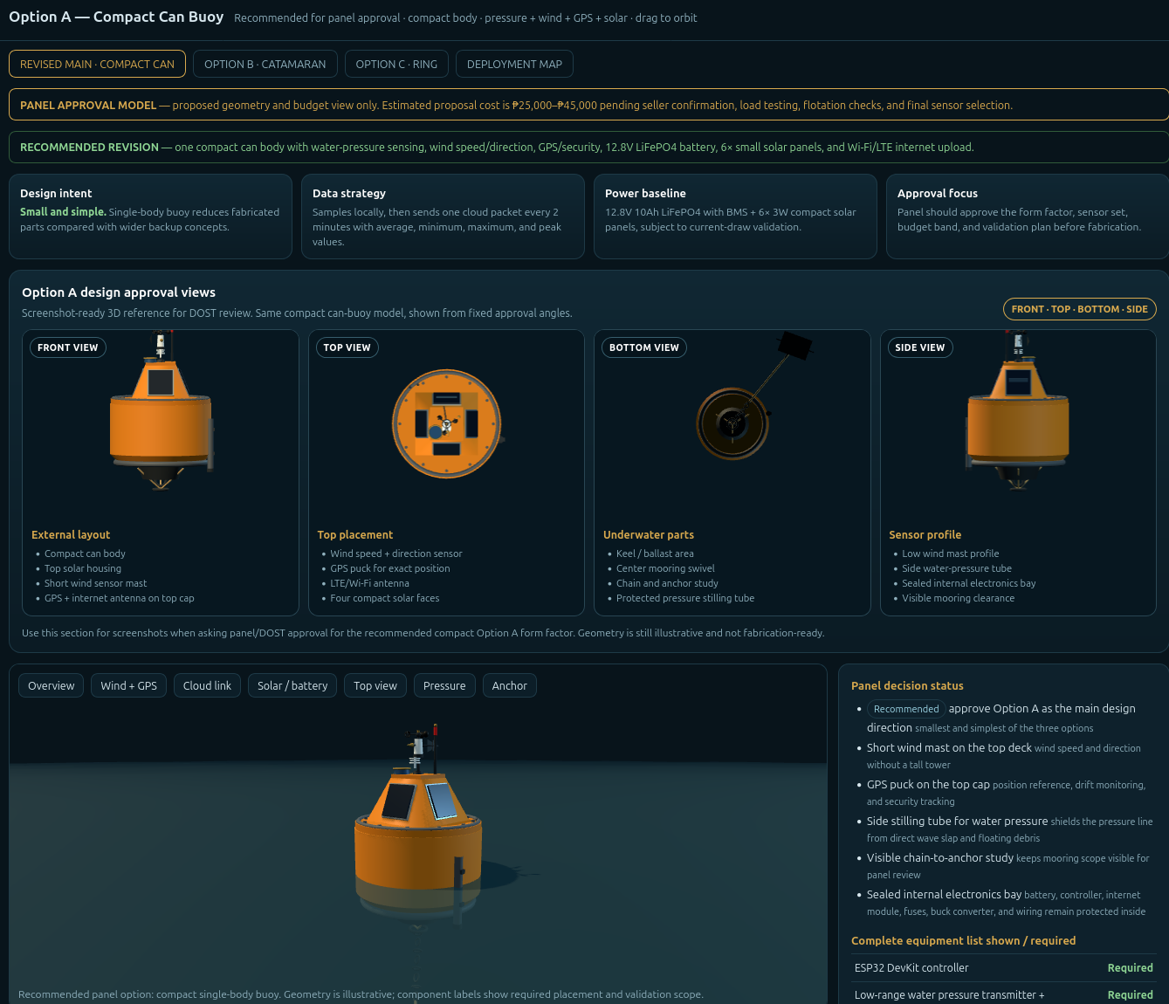 | Design description  Option A uses a compact single can body with a tapered top housing. The visible layout includes the water pressure stilling tube, compact wind sensor, GPS puck, internet antenna, solar faces, internal electronics bay, flashing marker light, and centered mooring attachment.  Why this option is good  - Simplest and smallest of the three options  - Lower fabrication complexity because it uses one main buoy body  - Best match to the DOST request for a simpler design  - Balanced centered mooring avoids one side pulling the buoy  - Most practical option for the budget target  Main limitations  - Less deck space than Option B  - Internal enclosure layout must be checked carefully  - Needs ballast and righting validation before fabrication  - Solar output and battery runtime must be confirmed by measured current draw  Approval note  Approve Option A as the main design direction, subject to validation of displacement, ballast, pressure sensor calibration, power budget, leak protection, and mooring sizing.

Option B Catamaran Backup
Backup design if the review panel prefers a wider platform with better deck access and higher initial stability.
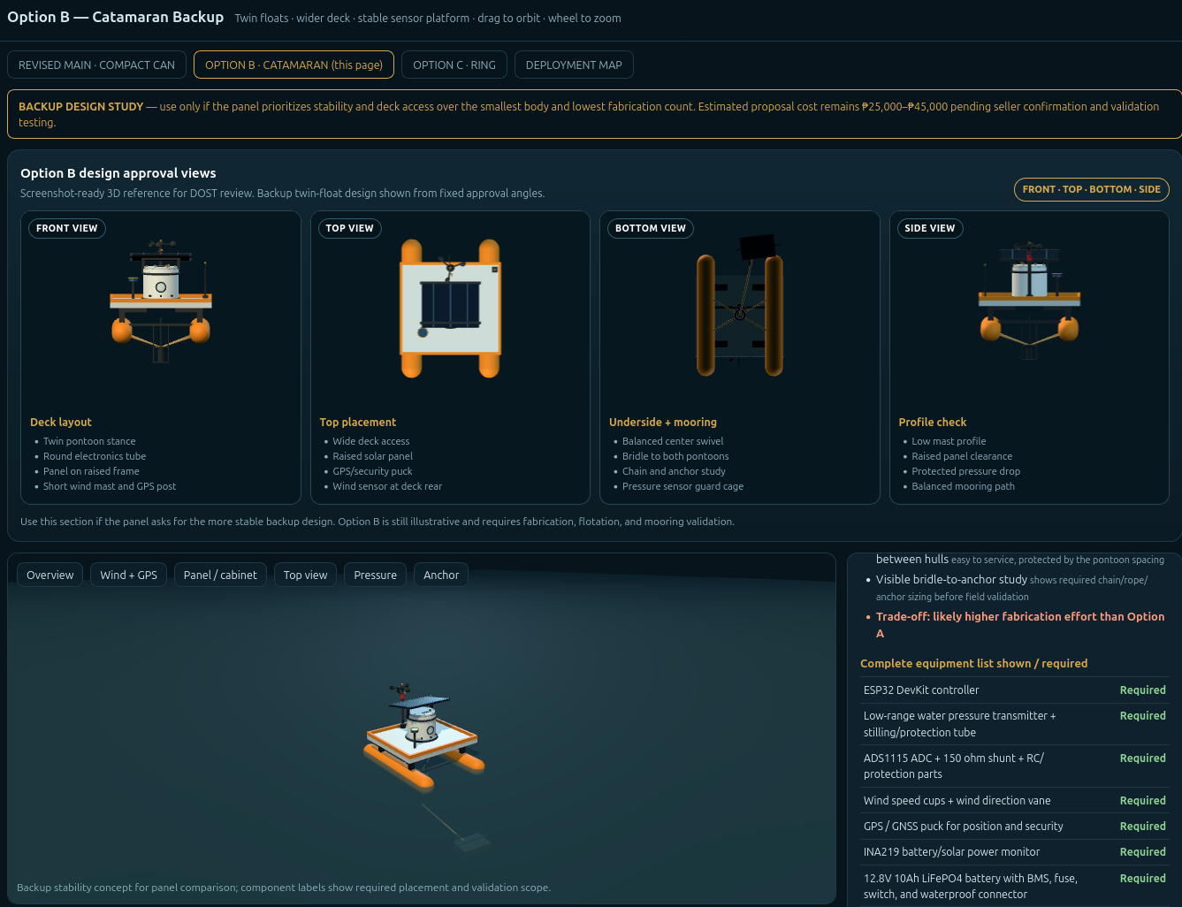 | Design description  Option B uses two pontoon floats connected by a deck. The electronics are placed in a round center enclosure with a raised solar panel frame, GPS post, wind sensor mast, protected pressure sensor between the pontoons, and a centered four point bridle leading to the anchor line.  Why this option is good  - Wider stance improves stability and service access  - Pressure sensor is protected between the two hulls  - Round electronics tube reduces wind-facing sharp edges  - Four point bridle shares anchor load between both pontoons  - Easier to inspect electronics and deck hardware  Main limitations  - Wider and less compact than Option A  - More fabricated pieces, joints, fasteners, and sealing points  - More transport and deployment space required  - May cost more to fabricate even if sensor set is the same  Approval note  Keep Option B as a backup design. It is technically understandable for panel review, but it should only replace Option A if stability and service access become more important than compact fabrication.

Option C Ring Buoy Backup
Backup design if the panel wants a ring buoy with an open moon pool and high waterplane area.
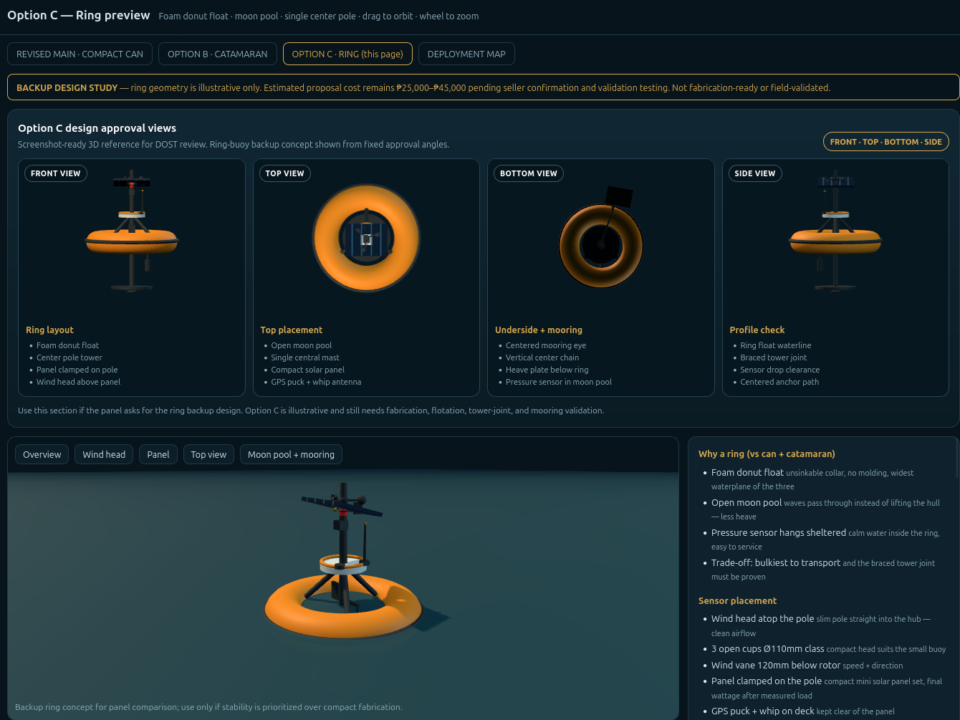 | Design description  Option C uses a foam ring float with an open center moon pool. A single center pole carries the solar panel, beacon, and wind head. The pressure sensor hangs inside the moon pool, while the mooring eye and chain are centered under the ring before the scope line continues to the anchor.  Why this option is good  - Ring shape gives a wide waterplane and strong visual stability  - Moon pool can reduce direct wave slap around the pressure sensor  - Centered mast and centered mooring path are easy to explain  - Foam ring concept may be inherently buoyant if fabricated correctly  Main limitations  - Bulkiest option for transport and deployment  - Center pole and tower braces need proof load testing  - Ring fabrication may be harder than the compact can body  - Open moon pool behavior must be validated in actual wave conditions  Approval note  Keep Option C as a design study only unless the panel specifically requests a ring buoy. It should not be the first build unless the team can validate the tower joint and ring fabrication method.

Recommended approval wording
Requested decision. The team requests approval to proceed with Option A Compact Can Buoy as the main proposal design, while keeping Option B Catamaran Backup and Option C Ring Buoy Backup as alternate concepts for comparison. Approval at this stage is for design direction and validation planning only, not final fabrication.
Validation condition. Before fabrication, the team will complete displacement and ballast checks, confirm the battery and solar runtime using measured current draw, validate the water pressure sensor and stilling tube, verify GPS and internet placement, and size the mooring chain, rope, and anchor for the selected deployment site.

Validation checklist before fabrication
Item to validate | What the team must check
Flotation and ballast | Confirm the selected body floats level after installing the battery, electronics bay, sensor tube, solar panels, beacon, and centered mooring hardware.
Power system | Measure actual ESP32, internet module, GPS, wind sensor, pressure sensor, and beacon current draw before finalizing the LiFePO4 battery and solar panel quantity.
Pressure sensor setup | Bench test the pressure sensor and stilling tube, then compare water-level readings against a manual reference during a controlled water test.
Wind and GPS placement | Verify that the anemometer has clear airflow above the body and that the GPS antenna has an unobstructed sky view.
Mooring and anchor | Size the chain, rope, and anchor based on the actual deployment depth, seabed condition, and expected wave/current load.
Leak protection | Inspect seals, cable glands, lid gasket, and electronics compartment before any field trial.

